Bangladesh University of Engineering and Technology

Department of Computer Science and Engineering

**CSE 316**

Microprocessors, Microcontrollers, and Embedded Systems Sessional

**Experiment 3**

**Basic use of ADC and LCD module with ATmega32.**

**GOAL:**

To understand the basic working principle of ADC and the LCD module.

**EXPERIMENTAL TOOLS AND MATERIALS:** ATmega32, 16×2 character LCD module, USBASP programmer, Trainer Board, Wires, Avr Studio, Extreme Burner, Potentiometer.

**BASIC DESCRIPTION:**

In this experiment you will have to generate a variable voltage from 0 to 4V using a potentiometer. You will measure this voltage using ADC and display the voltage in the LCD segment. You will also continuously monitor the voltage using a voltmeter. You should use the DVM (digital volt meter) from the trainer board. We will change the voltage using the pot and the reading of ADC from the LCD segment should be close to the value shown in the DVM.

**LCD Module Basics:**

You should check out [this](https://electrosome.com/interfacing-lcd-atmega32-microcontroller-atmel-studio/) tutorial. You will be using the 4 bit mode. Essentially, you will use their library file and connect your LCD module according to the given diagram. You do not need to use crystal. The connections of VSS, VDD, VEE, and D0-D3 are also not needed. In fact the available LCD modules in  
the lab (and also in the market) have these connections built-in. So you do not need to worry about those. The connection summary is given in the following table.

| LCD Module Pin | ATmega32 Pin |
| --- | --- |
| RS | PC6 |
| RW | GND |
| E | PC7 |
| D4-D7 | D4-D7 |
| VCC | 5V |
| GND (both) | GND |

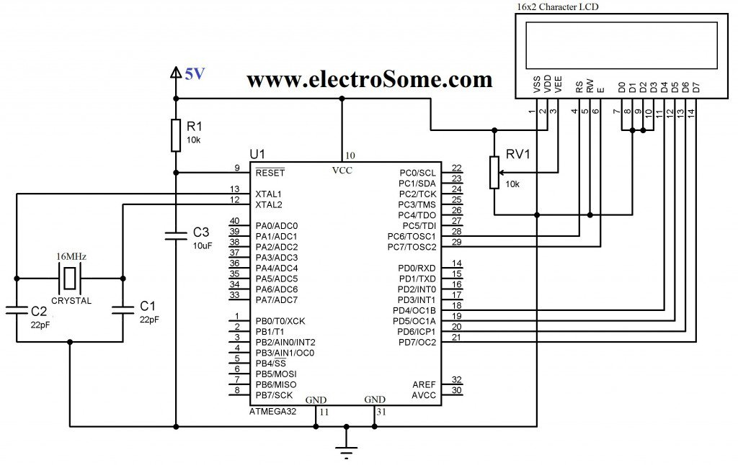

**Figure:** Circuit diagram of the LCD module. You do not need to use crystal. The connections of VSS, VDD, VEE, and D0-D3 are also not needed. In fact the available LCD modules in the lab (and also in the market) have this connections built-in. So you do not need to worry about those.

**ADC Basics:**

The basics were covered in the theory class. Do necessary calculations according to your clock speed and configuration. If you use the internal 5V as ADC source. You will have to connect AVCC (PIN30) to 5V and GND (PIN 31 and PIN 11) to 0V. You can connect the AREF pin (PIN32) to a capacitor e.g., 10μF or, 1μF, however it is optional.

**PROCEDURE:**

1. First create a 4V source from the trainer board. Then create a variable voltage source of 0-4V using the potentiometer. Ensure the potentiometer is working by checking its output in the DVM of trainer board.
2. Connect the LCD module to your microcontroller. Remember to use the power source of trainer board. The USB ASP will not be able to drive the LCD module. Write the necessary code to display a simple string, e.g., “Patience!!” to check the LCD module is working. Show it to the lab teachers.
3. Complete the necessary ADC connections and display the variable voltage both in the DVM and your LCD module.

**MISCELLANEOUS:**

1. The USB ASP may not be able to drive the LCD module properly. You should use the trainer board.
2. The connection to the LCD segment is crucial. Without proper connection it will not work. Upon given VCC and GND and the backlight switch on, the LCD module should lit the backlight on and show a blank screen. Using female to male jumper wires to connect the LCD module can be subject to loose connection. Setting the LCD module directly to the breadboard seemed to work better.
3. There is a pot in the LCD module. You can use it to adjust the contrast.
4. Never input a voltage greater than 5V to your ADC input.
5. Some pins of PORTC can not be used for I/O directly. First the JTAG has to be turned off.   
   One way is to uncheck the JTAG box while writing the fuse bits, the second is to write a 1 to the JTD bit twice consecutively. MCUCSR = (1<<JTD); MCUCSR = (1<<JTD);   
   For more details refer to:   
   <http://www.avrfreaks.net/forum/jtag-enablingdisabling-atmega32-and-fuse-settings-solved>
6. You do not need to bother about FUSE bits. By default it is set to: E199  
   If the JTAG Interface is disabled it will be set to: E1D9. You can calculate fuse bit from this online tool: <http://www.engbedded.com/fusecalc/>